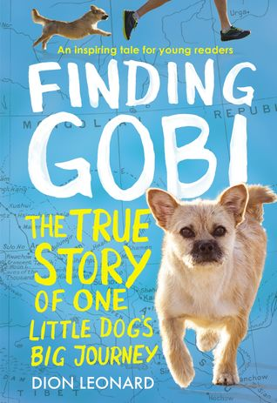 | Finding Gobi The True Story of One Little Dog’s Big Journey | Dion Leonard | Westminster  636.7 Leo | Anythink  J Pets Dogs | Trailer link  https://safeshare.tv/submit?url=https://www.youtube.com/watch?v=RKpkFoikwEA
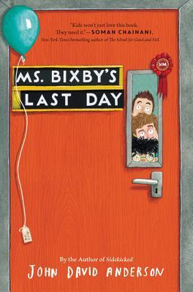 | Ms. Bixby’s Last Day | John David Anderson | And-j  e-book  audio overdrive | JF Anderson  Audio e-book (hoopla)
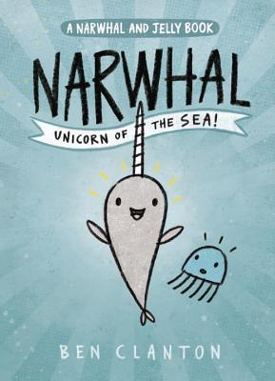 | Narwhal: Unicorn of the Sea | Ben  Clayton | Cla-Nar | J Graphic Narwhal | http://www.scholastic.com/bookfairs/books/book-trailers/narwhal-unicorn-of-sea
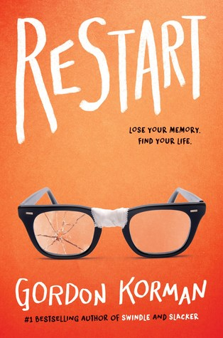 | Restart | Gordon Korman | Kor-G Res  e-book | JF Korman | https://www.youtube.com/watch?v=Rf56kldZo78&t=3s
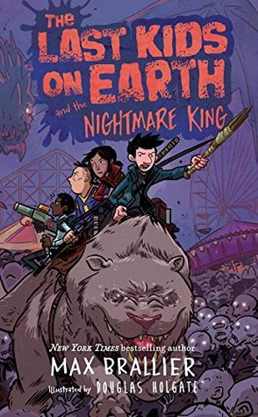 | Last Kids on Earth and the Nighmare King  Book 3 | Max Brallier & Dennis Holgate | Bra-Las 3  e-book  audio CD | JF Brallier | https://www.youtube.com/watch?v=zwp2xLaHzyc
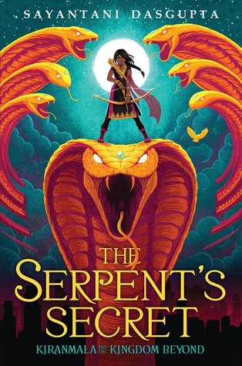 | The Serpent’s Secret: Kiranmala and the Kingdom Beyond Book 1 | Sayantani Dasgupta | J Fan Dasgu Kiran 1  e-book  audio CD  overdrive | JF Fantasy Dasgupta  Audo CD  E book  E audio  playaway | https://www.youtube.com/watch?v=pBvi5-ktn5Y
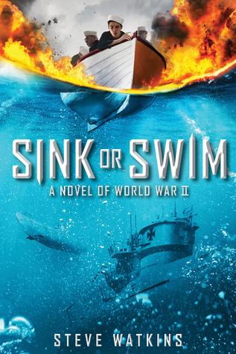 | Sink or Swim: A Novel of World War II | Steve Walkins |  | JF History Watkins | https://www.youtube.com/watch?v=S9anxCXhHns
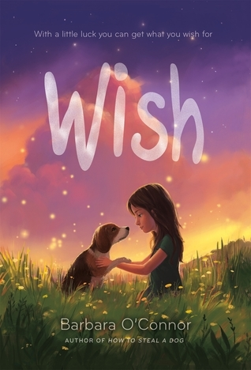 | Wish | Barbara O’Connor | e-book | JF O’Connor | https://www.barbaraoconnor.com/index.html
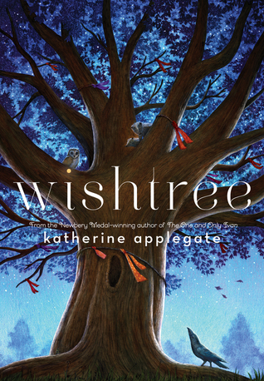 | Wishtree | Katherine Applegate | App-K Wis  e-book  audio CD  overdrive | JF Fantasy Applegate  Audio CD  E book  E audio  playaway | https://www.youtube.com/watch?v=-P5TSKKBIyo
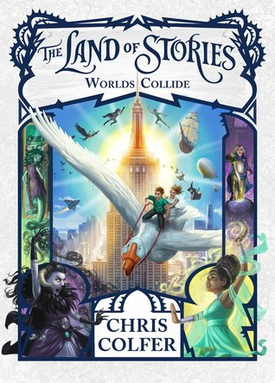 | Land of Stories 6: World’s Collide | Chris Colfer | Col-Lan 6  Audio CD  Overdrive | JF Fantasy Colfer  Audio CD  E book  E audio  playaway | http://thelandofstories.com/news/2017/7/5/the-land-of-stories-official-party-kit

