 | https://www.youtube.com/watch?v=BkTSC-Dl3AY |  | Blended RL 4.0 IL 3-7 610L  Piano-prodigy Isabella, eleven, whose black father and white mother struggle to share custody, never feels whole, especially as racial tensions affect her school, her parents both become engaged, and she and her stepbrother are stopped by police
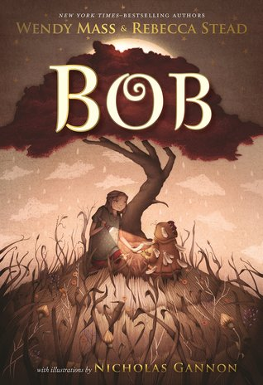 | https://www.youtube.com/watch?v=0h_MO3vc4G0 | https://images.macmillan.com/folio-assets/teachers-guides/9781250166623TG.pdf | Bob RL3.9, 590L Visiting her grandmother in Australia, Livy, ten, is reminded of the promise she made five years before to Bob, a strange, green creature who cannot recall who or what he is.
 | https://www.youtube.com/watch?v=Xe3SD8XLD3I |  | Ground Zero RL4.8 690L  Alternating chapters have Brandon visiting his dad on the 107th floor of the World Trade Center on September 11, 2001 when the attack comes and Reshmina gowing up in Afghanistan in the aftermath of that attack. She dreams of peace, becoming a teacher and escaping her village and the narrow role that the Taliban believes is appropriate for women. Both are struggling to survive and are changed forever by the events of 9/11.
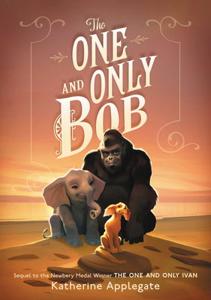 | https://www.youtube.com/watch?v=p8UKRHQ66Mw | https://www.youtube.com/watch?v=AijUV-dbERI | One and Only Bob RL 3.9 570L Bob sets off on a journey to find his sister.
 | https://www.youtube.com/watch?v=SPpIIkEztV0 |  | Song for a Whale 2019  RL 5.3 800L Twelve-year-old Iris and her grandmother, both deaf, drive from Texas to Alaska armed with Iris's plan to help Blue-55, a whale unable to communicate with other whales.
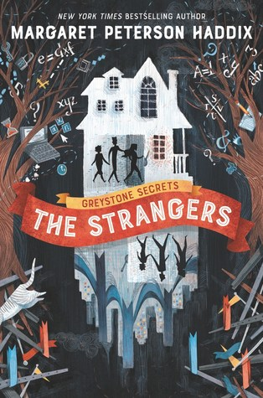 | https://www.harpercollins.com/pages/childrens-the-greystone-secrets-series |  | Strangers – RL5.1 730L Greystone Secrets (Book 1)  "Told from separate viewpoints, [this is the story of] Chess, Emma, and Finn Greystone, ages twelve, ten, and eight, [who] investigate why their mother went missing and uncover their ties to an alternate world.”
 | https://www.youtube.com/watch?v=J_jMx6d2TBA |  | Three Keys: Front Desk volume two follows Mia to sixth grade where she and her best firend Lupe continue to run the Desk at the Calivista Motel, and so much more.  RL 4.8, IL middle grade 710L
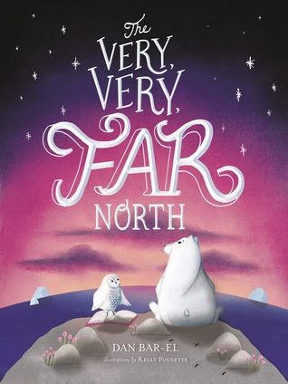 | https://www.youtube.com/watch?v=twzSXDEJU5w |  | Very Very Far North RL 5.9 860L  As Duane, a polar bear, explores his new home he makes friends with the wide variety of creatures he encounters, despite their varied personalities
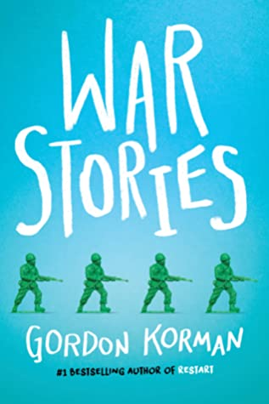 | https://www.youtube.com/watch?v=1dL1026nO34 | https://www.youtube.com/watch?v=bE5r7n-K6Tg | Visiting the small French village that his veteran grandfather helped liberate during World War II, an avid young player of war video games begins questioning his family's perspectives about his grandfather's heroism when he uncovers the rest of the story.
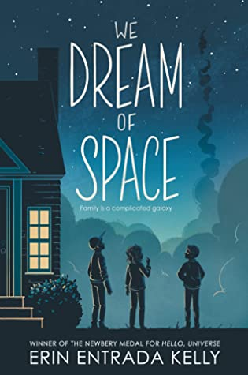 |  |  | We Dream Of Space RL. 4.6 Lexile  Joining their fellow seventh graders to watch the 1986 Challenger launch, three siblings struggle with respective difficulties including falling grades, an out-of-control temper and depressed NASA ambitions.

