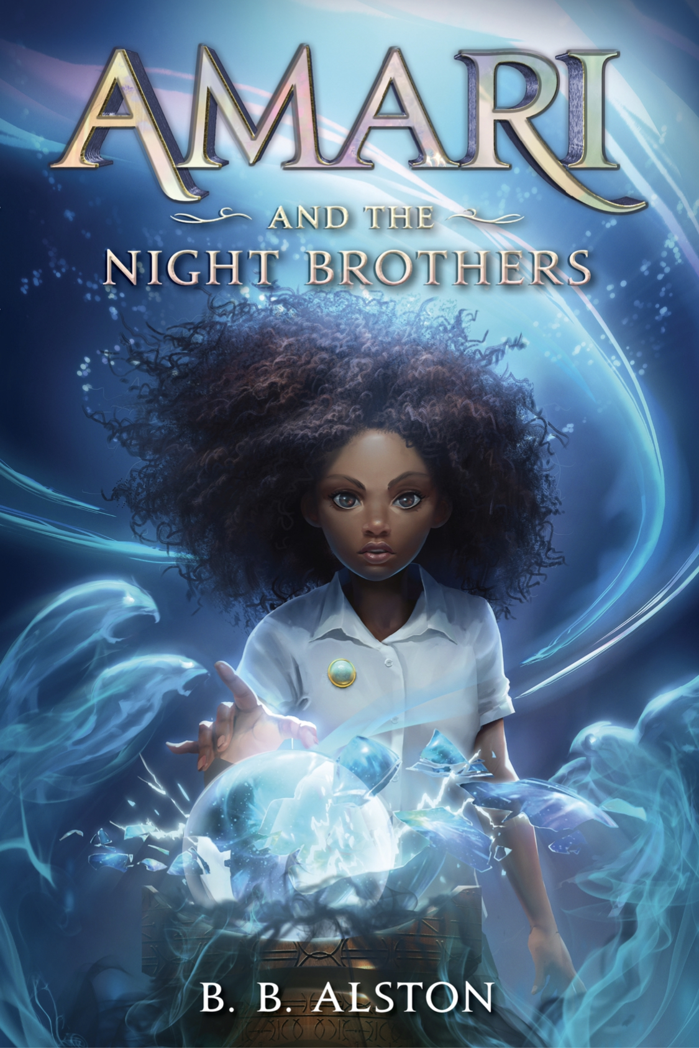 | Amari and the Night Brothers - https://www.harpercollins.com/products/amari-and-the-night-brothers-b-b-alston?variant=39307357880354
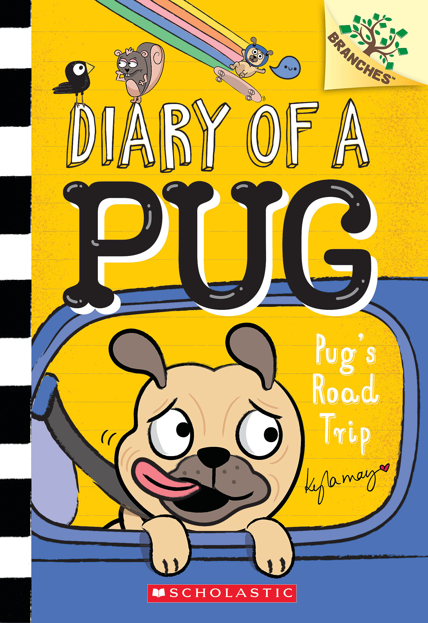 | Pug’s Road Trip - https://www.scholastic.com/site/branches/diary-of-a-pug.html
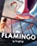 | The Flamingo - https://www.penguinrandomhouse.com/books/621154/the-flamingo-by-guojing/  https://www.youtube.com/watch?v=Rt8Tpvfie8k
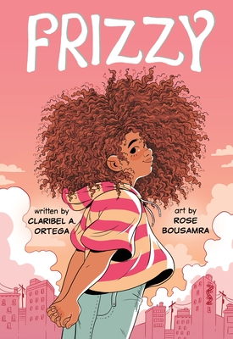 | https://www.youtube.com/watch?v=Rt8Tpvfie8k  https://www.claribelortega.com/books
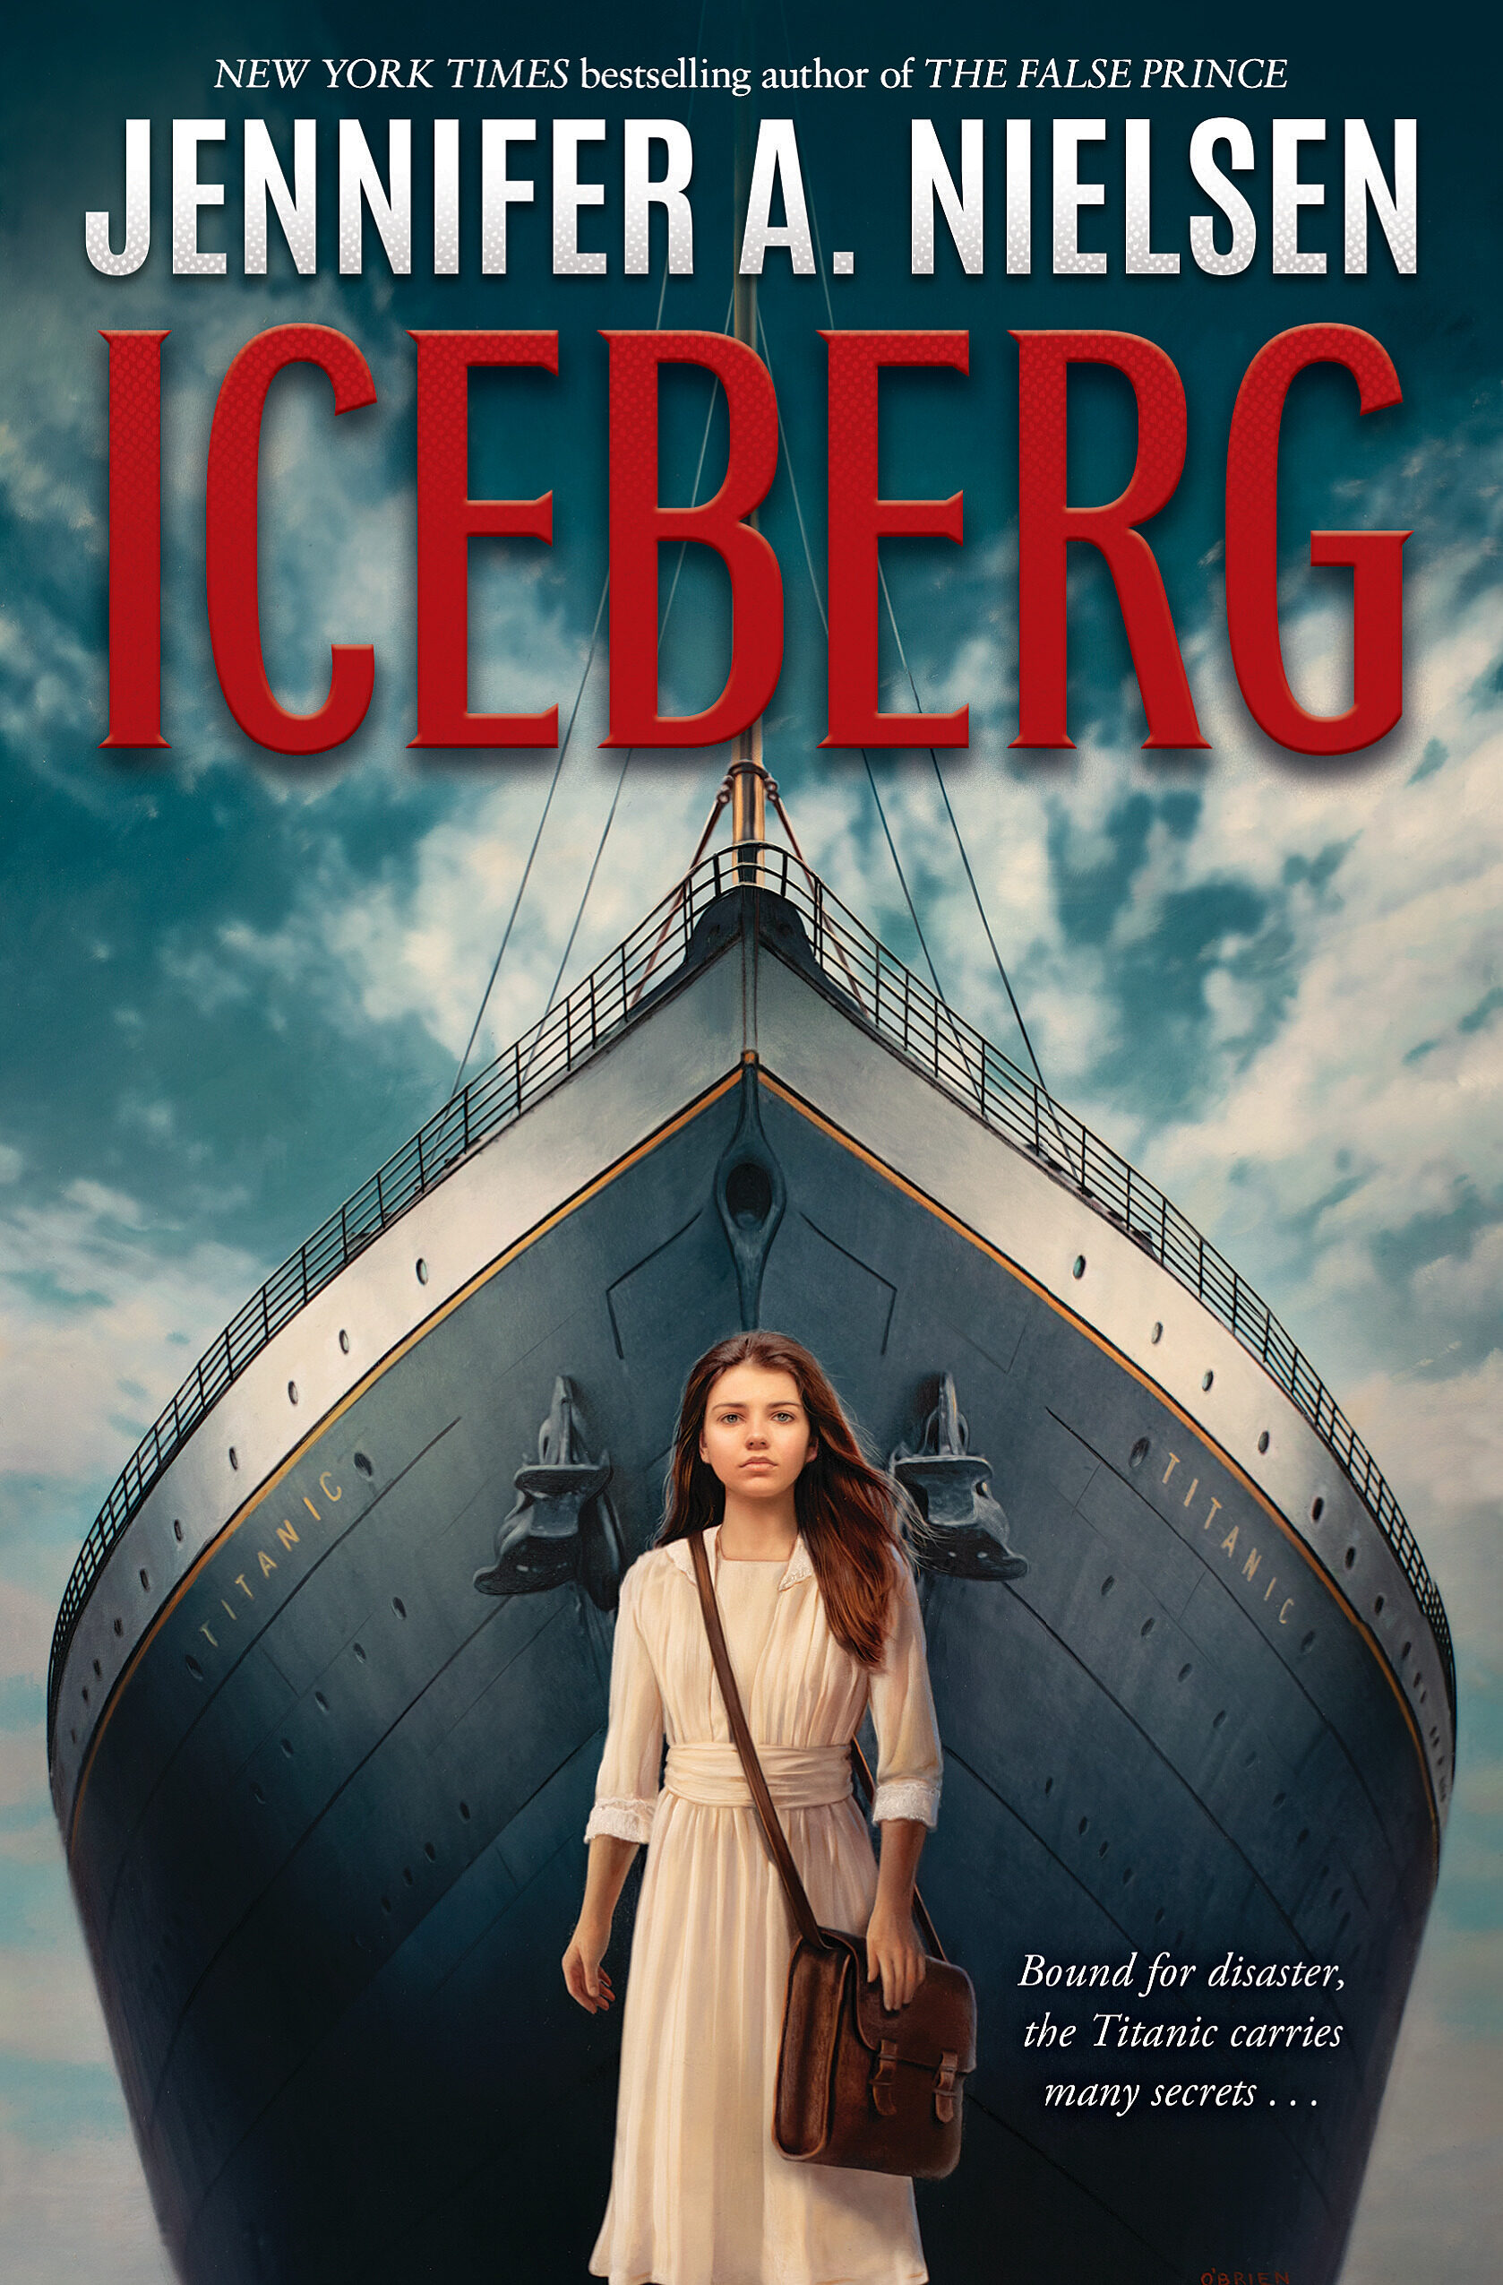 | https://www.youtube.com/watch?v=neCUlHC2Npk
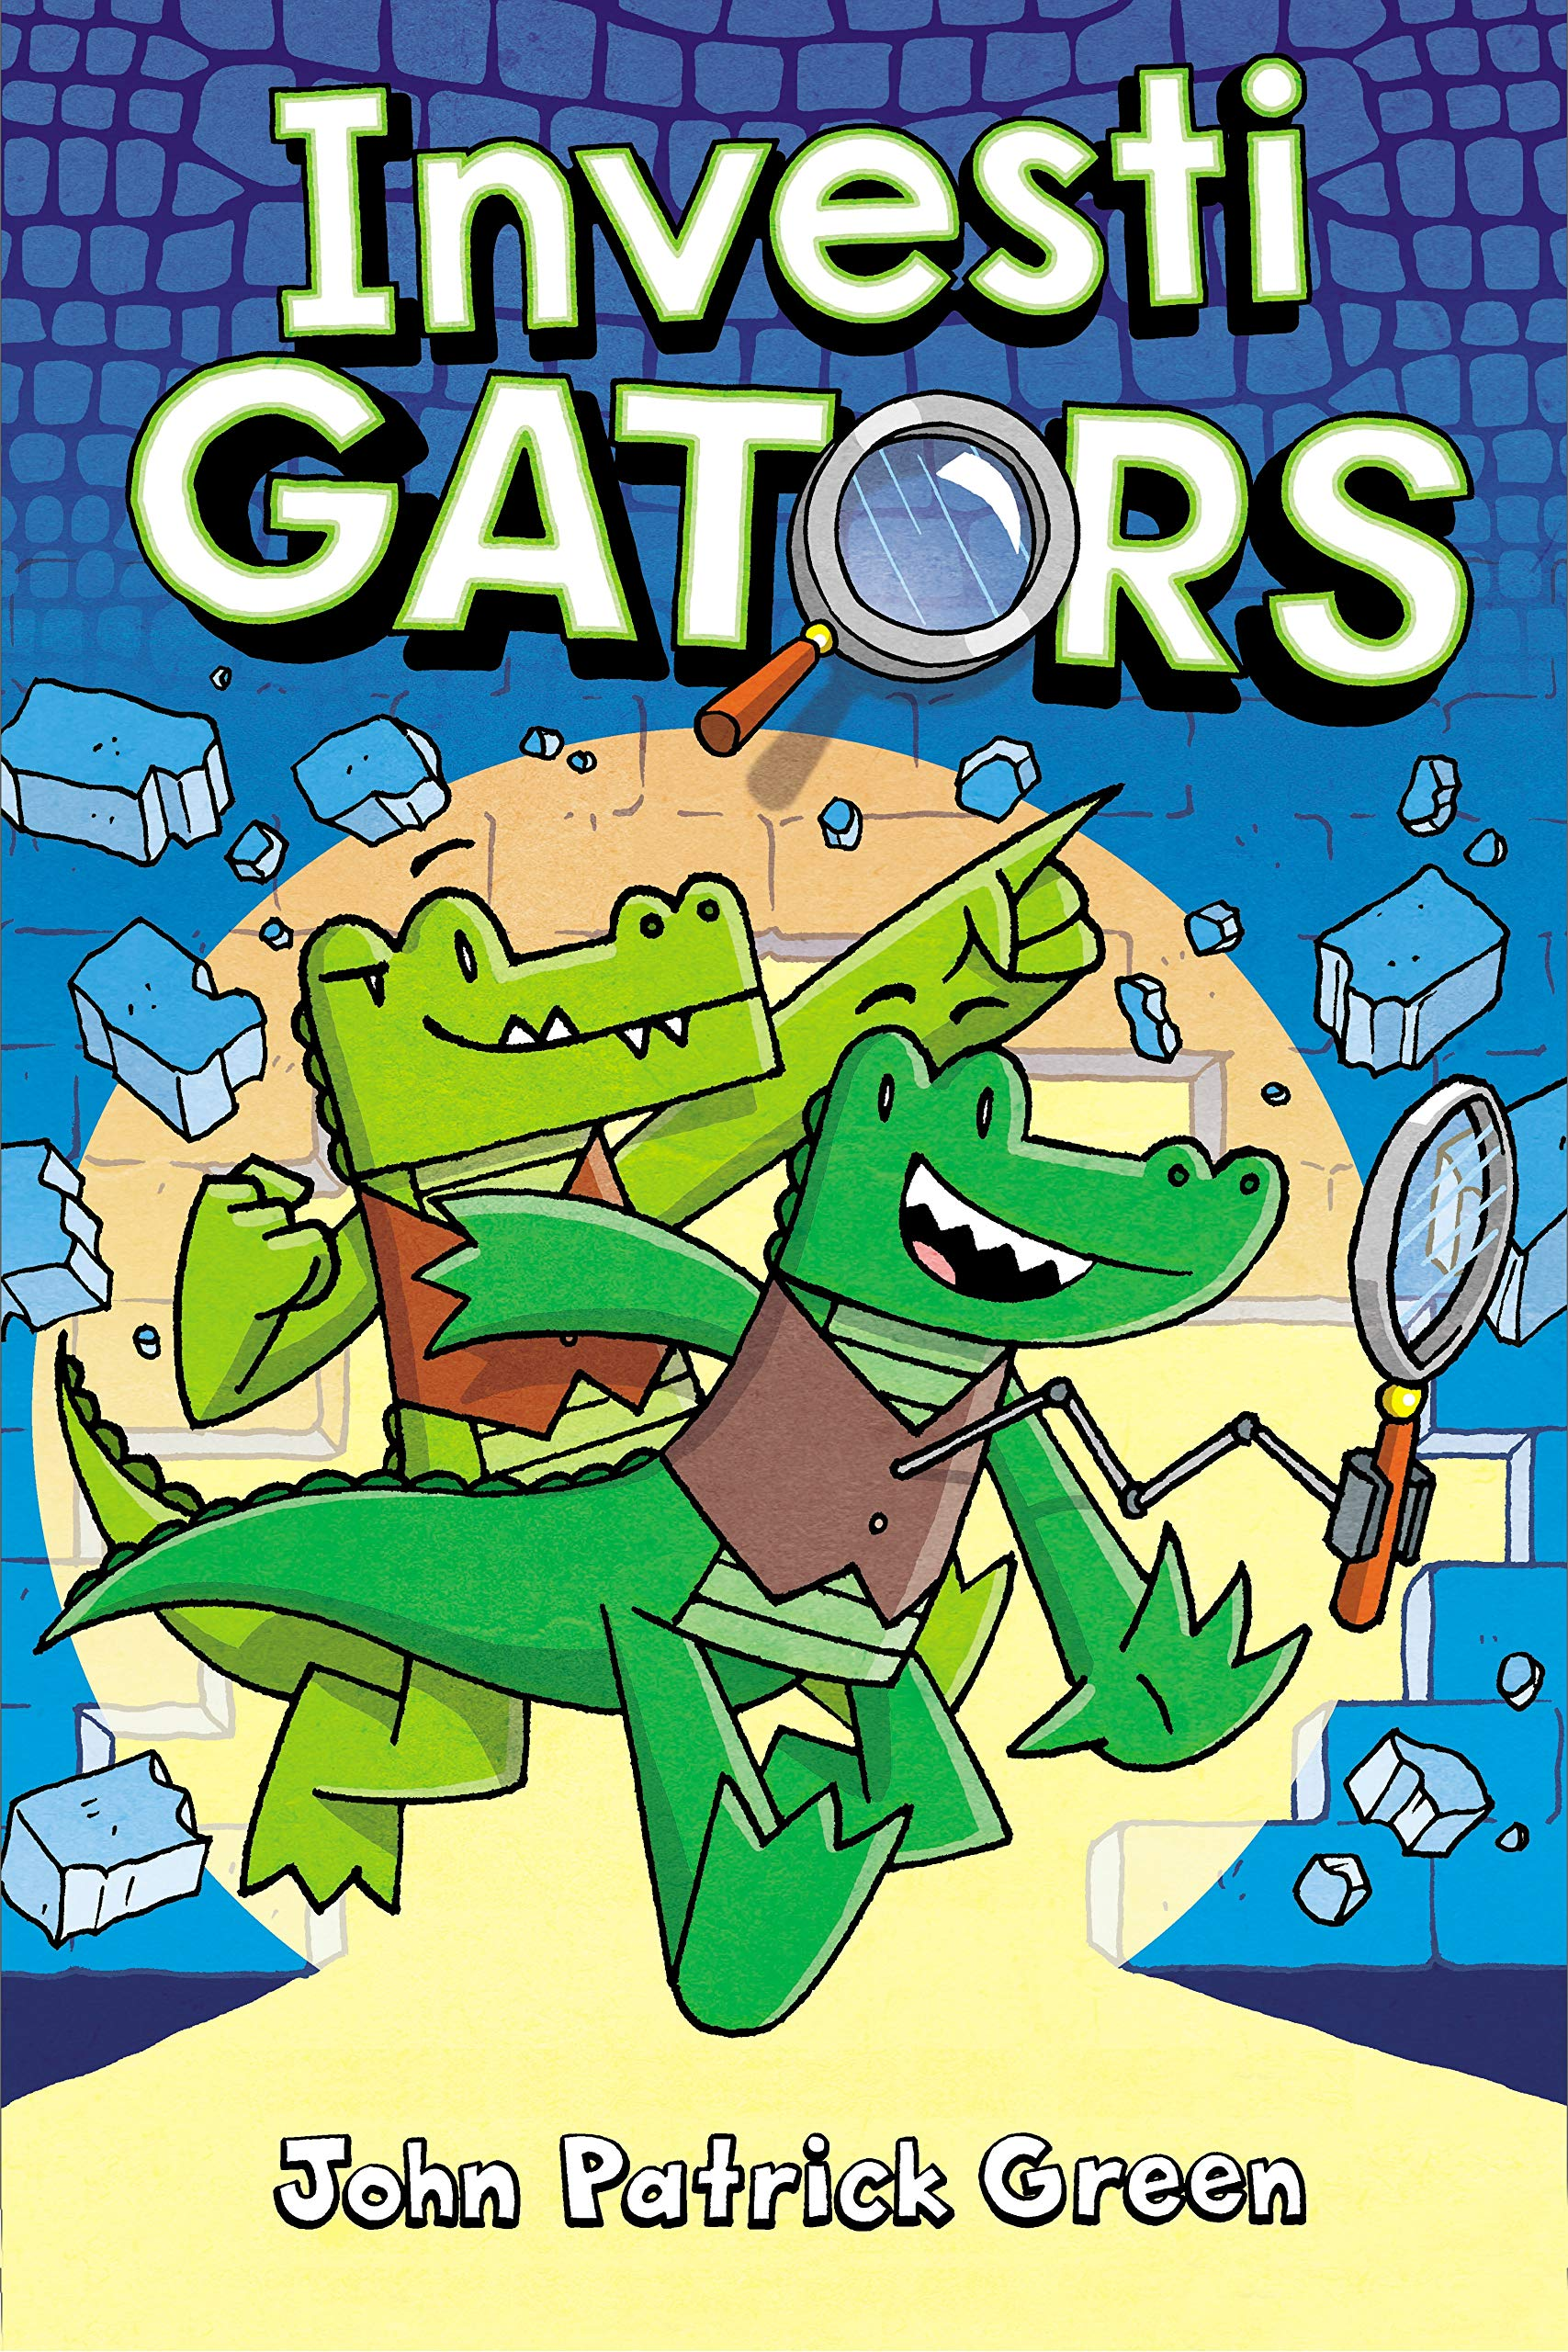 | https://investigatorsbooks.com/book/investigators/
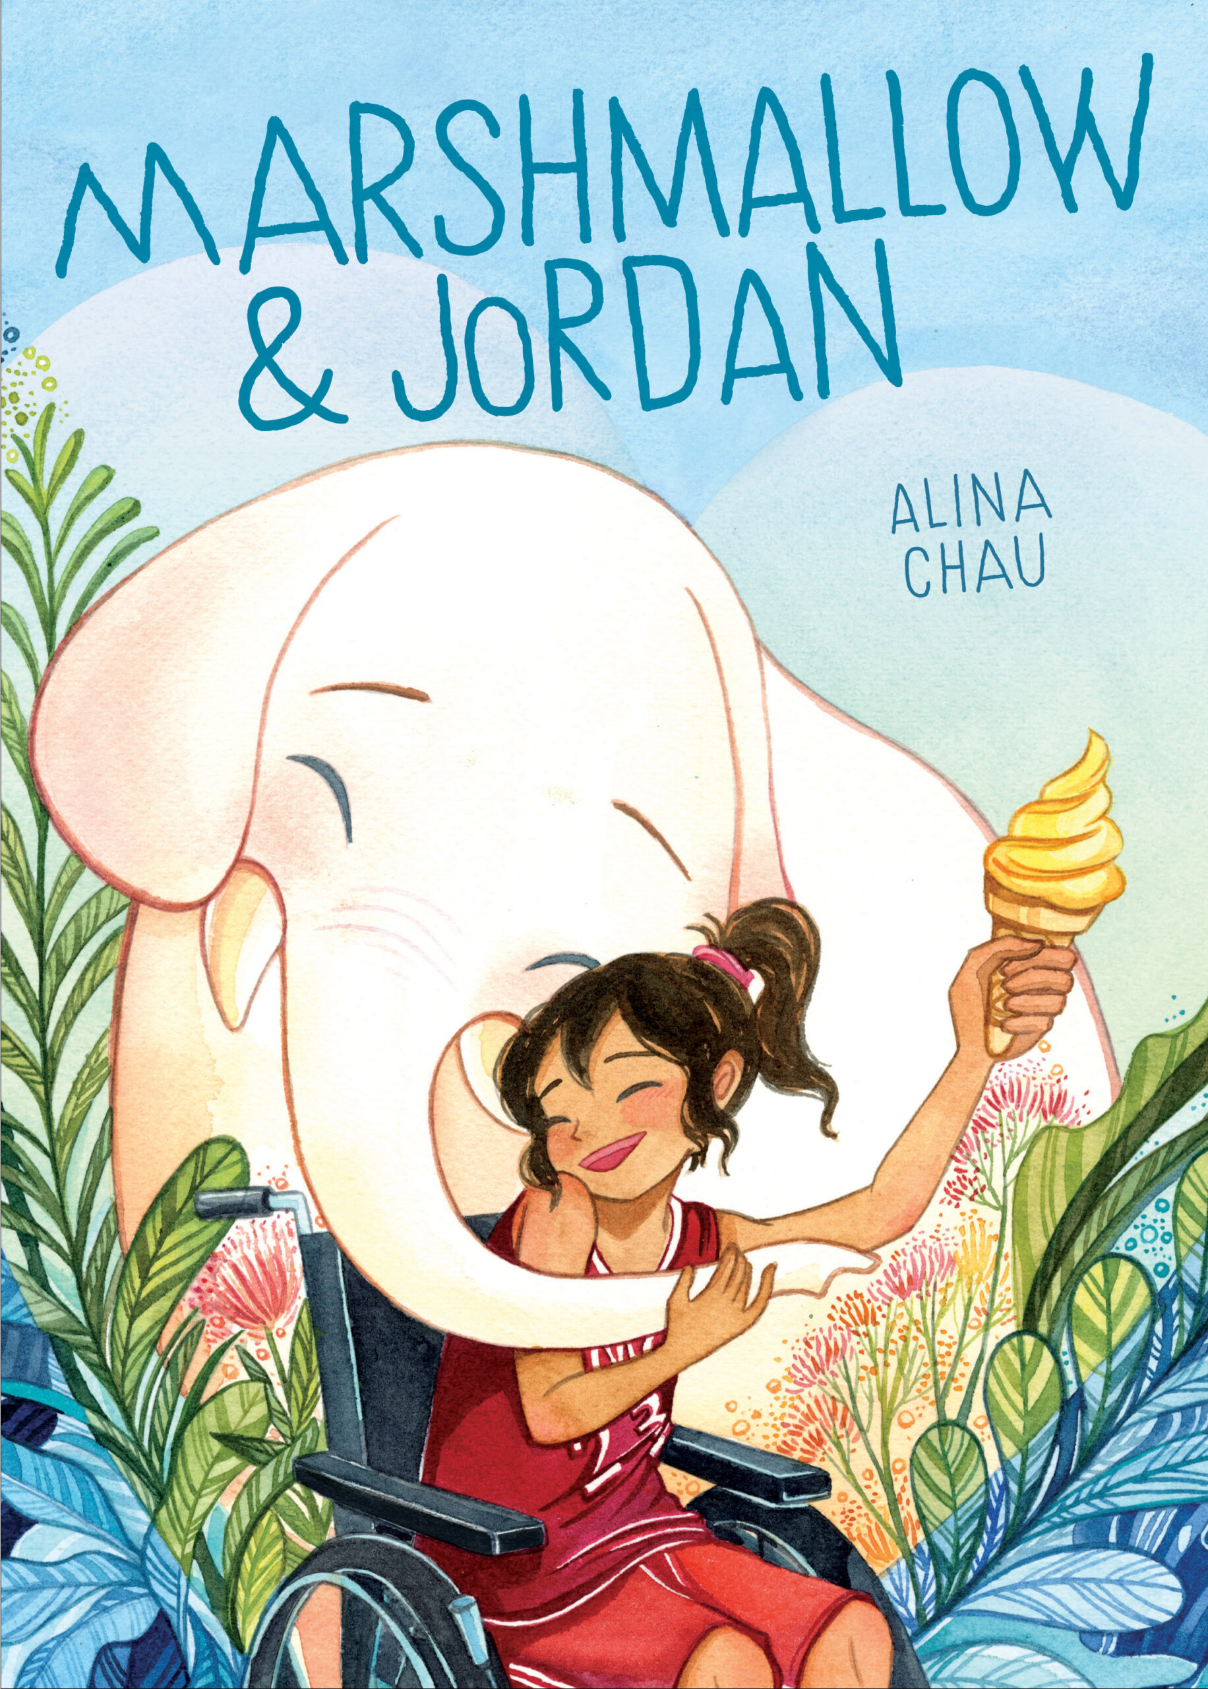 | https://us.macmillan.com/books/9781250300614/marshmallowjordan  https://www.youtube.com/watch?v=Xe6R4cz4rFc
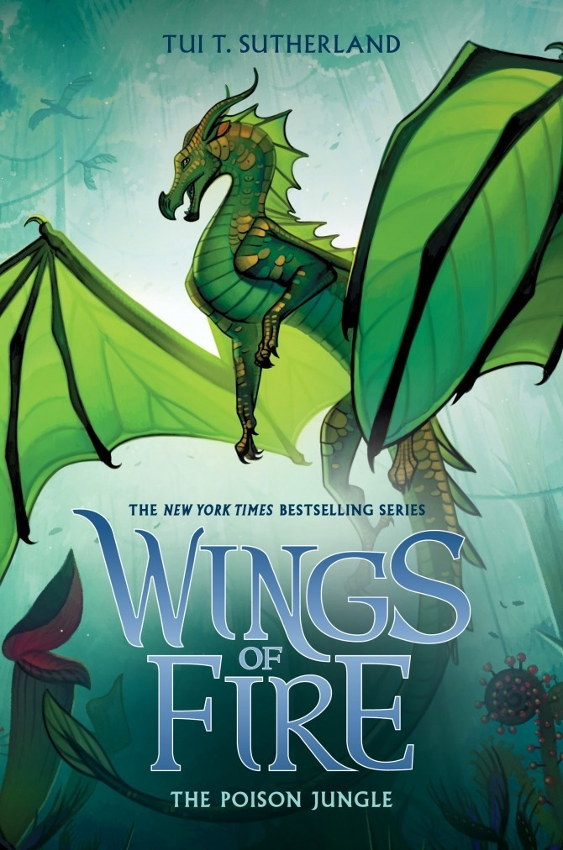 | https://tuibooks.com/  https://kids.scholastic.com/kid/books/wings-of-fire/  https://www.youtube.com/watch?v=nG2-pF1kjyg
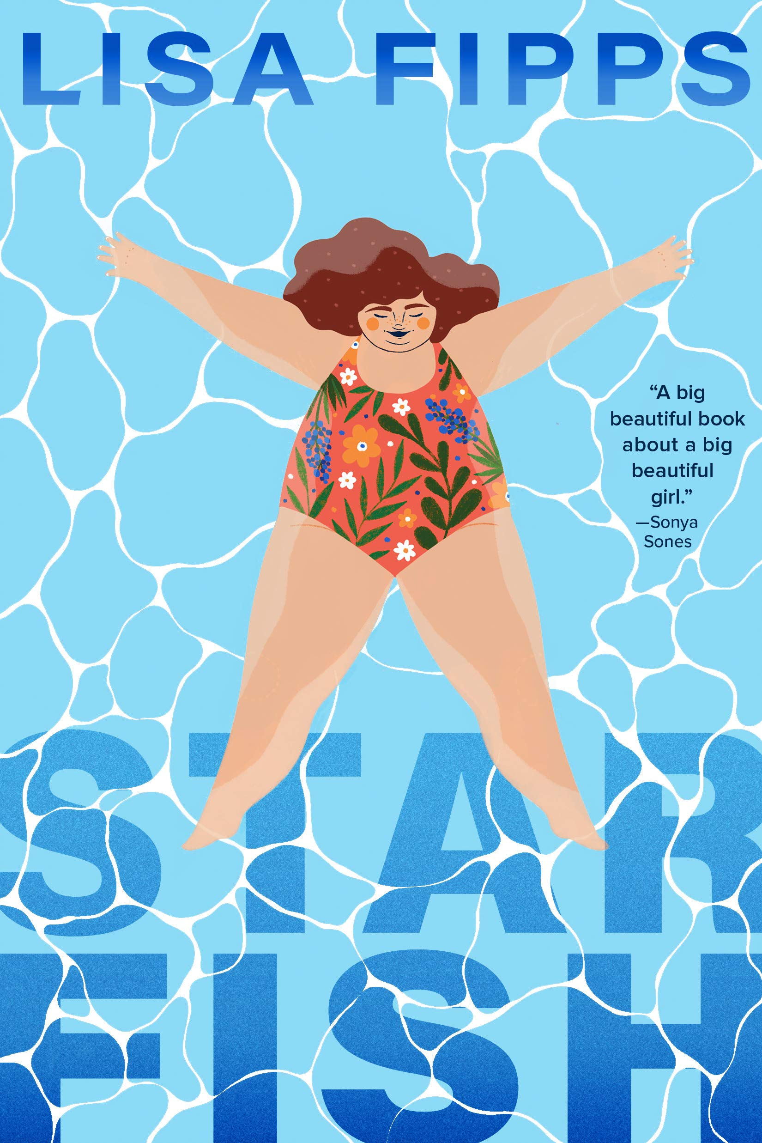 | Peek inside at Penguin/Random House with Teacher's Guide
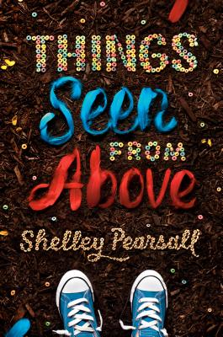 | 2 minute trailer by BPLibraryKids  Shelley Pearsell Website

