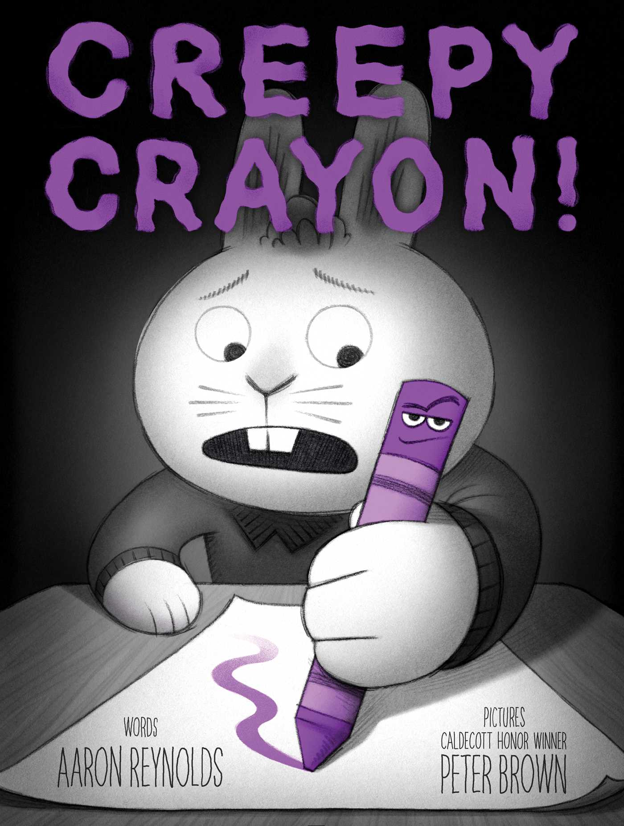 | https://youtu.be/En5BP2yVpuA  https://www.youtube.com/watch?v=1pgeQsBuhmk
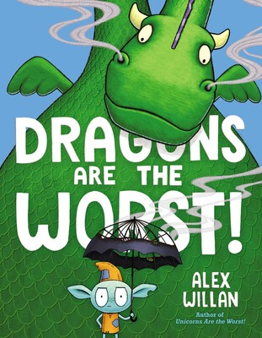 | Story guide from Simon & Schuster  https://d28hgpri8am2if.cloudfront.net/tagged_assets/8659349/9781534485112_cg_dragons%20are%20the%20worst%20discussion%20guide.pdf  15 minute Storytime with Alex Willan:  https://www.facebook.com/watch/?v=2984907295112732
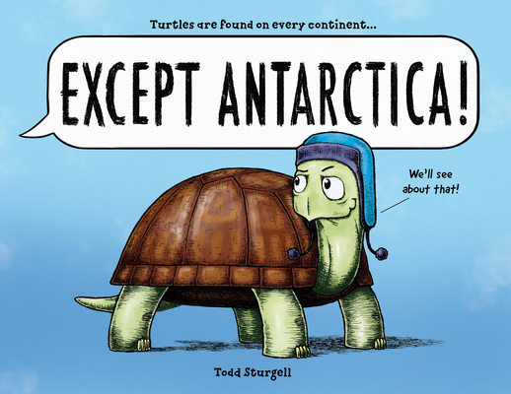 | 9 min read aloud https://www.youtube.com/watch?v=Hh9RDNRY9UQ
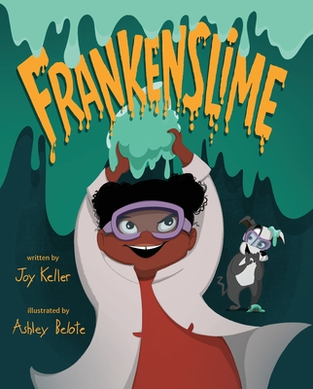 | 4 min. Sankofa Read Aloud https://youtu.be/UmB08MN9Ajs
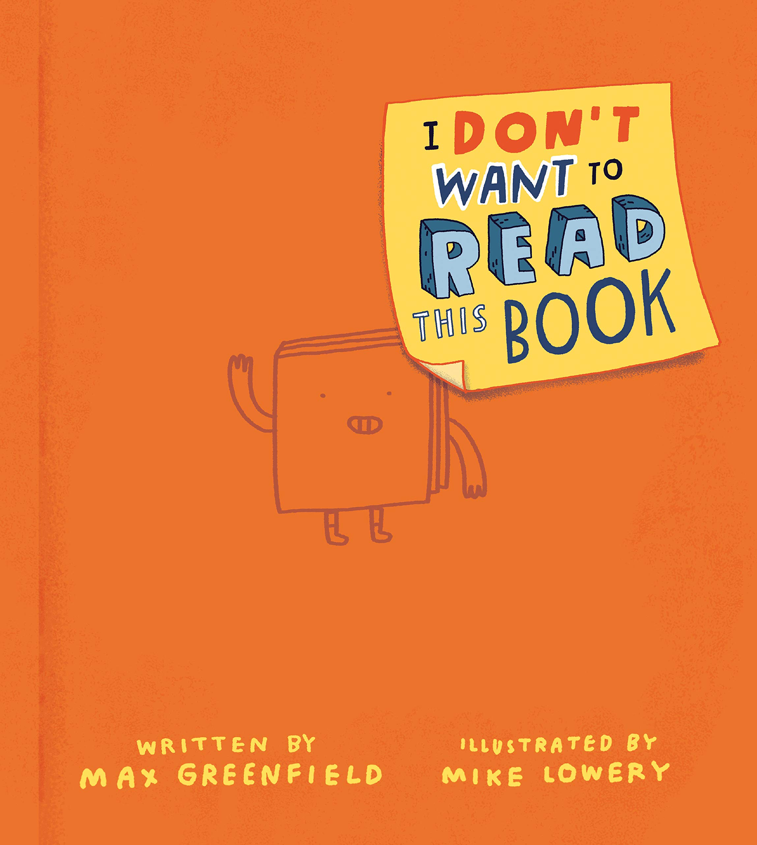 | 5 min. BN Read Aloud by Max Greenfield https://www.youtube.com/watch?v=-PNFW3fHt_Y
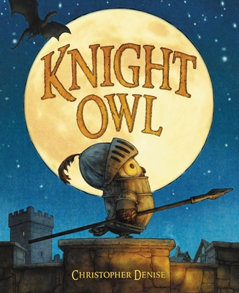 | https://www.youtube.com/watch?v=fpL1nl3J5FI
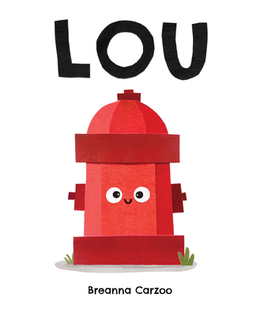 | https://www.youtube.com/watch?v=RcfIecr9F4k  https://www.youtube.com/watch?v=mPU8R5PR5tI
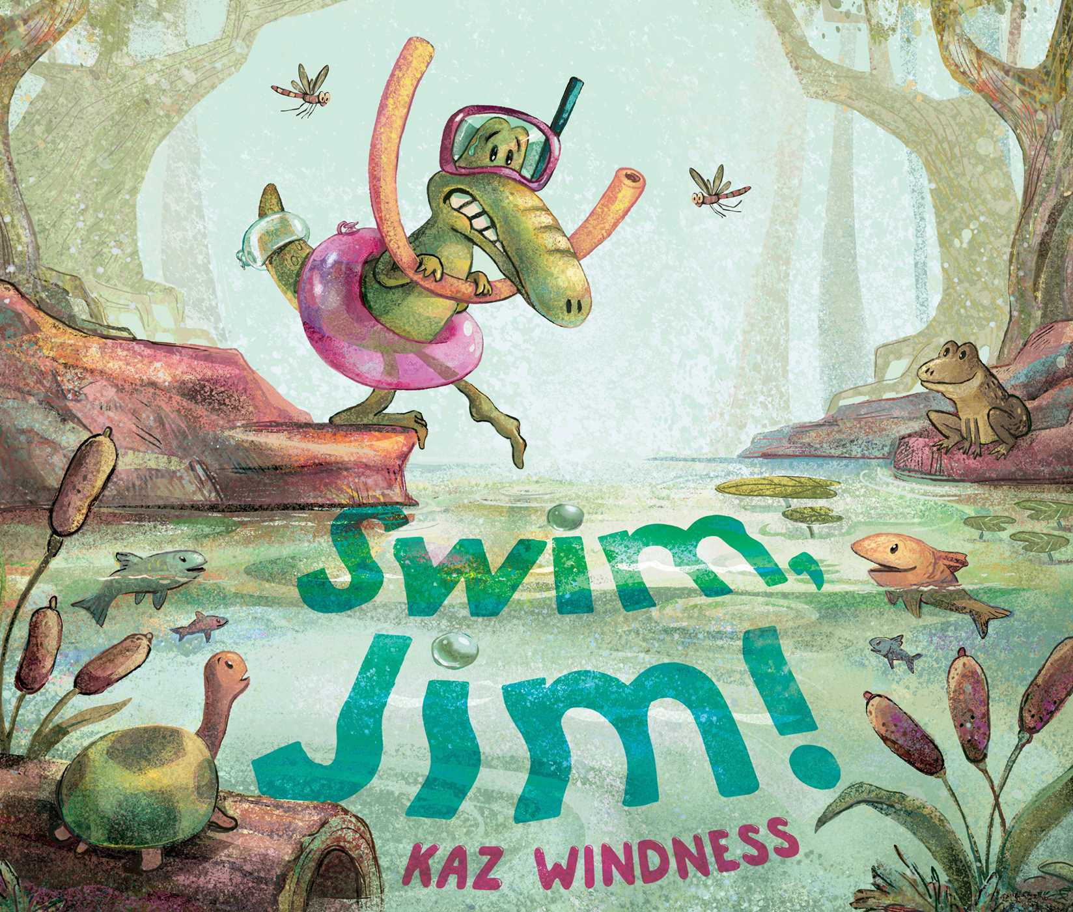 | https://www.youtube.com/watch?v=FkyXYyTMVvE&t=3s  https://karenwindness.wordpress.com/2022/05/29/swim-jim-activity-sheet/
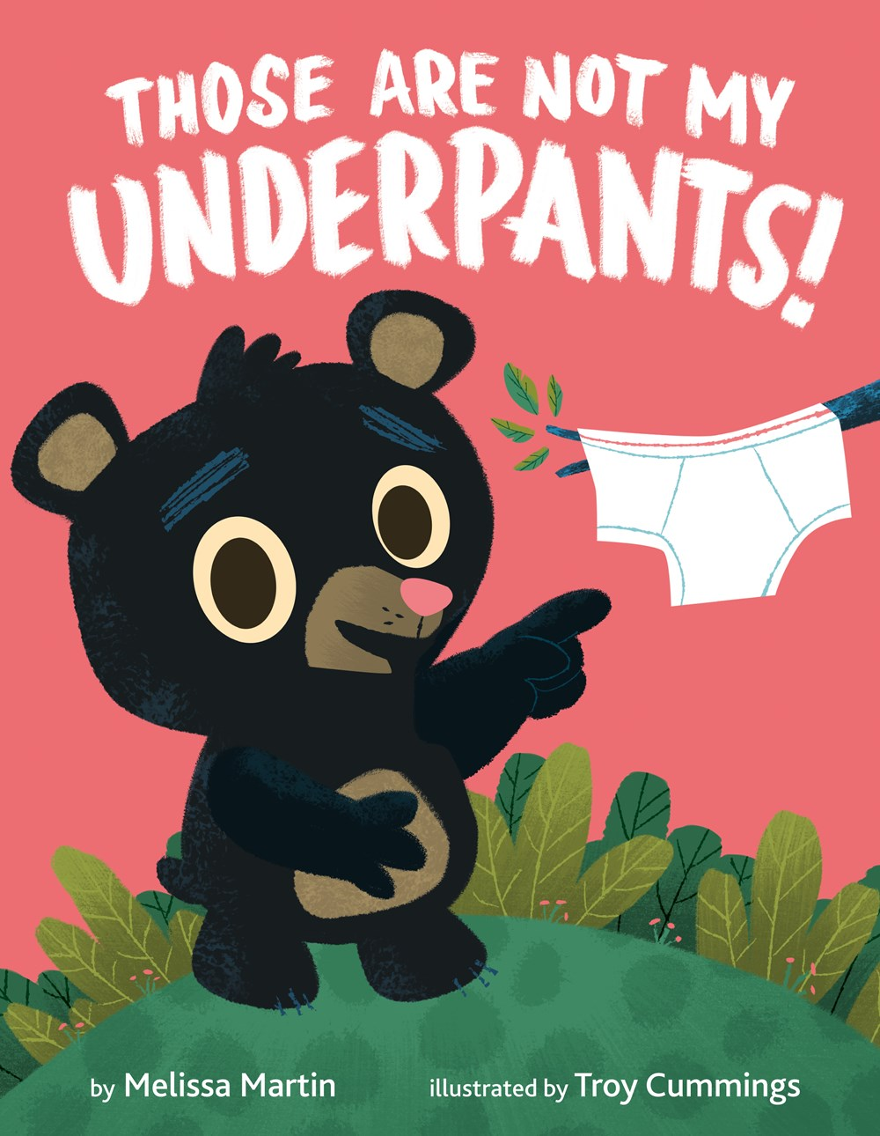 | 5 min. read aloud with City Councilman https://www.youtube.com/watch?v=JC7Qza8Rsl8
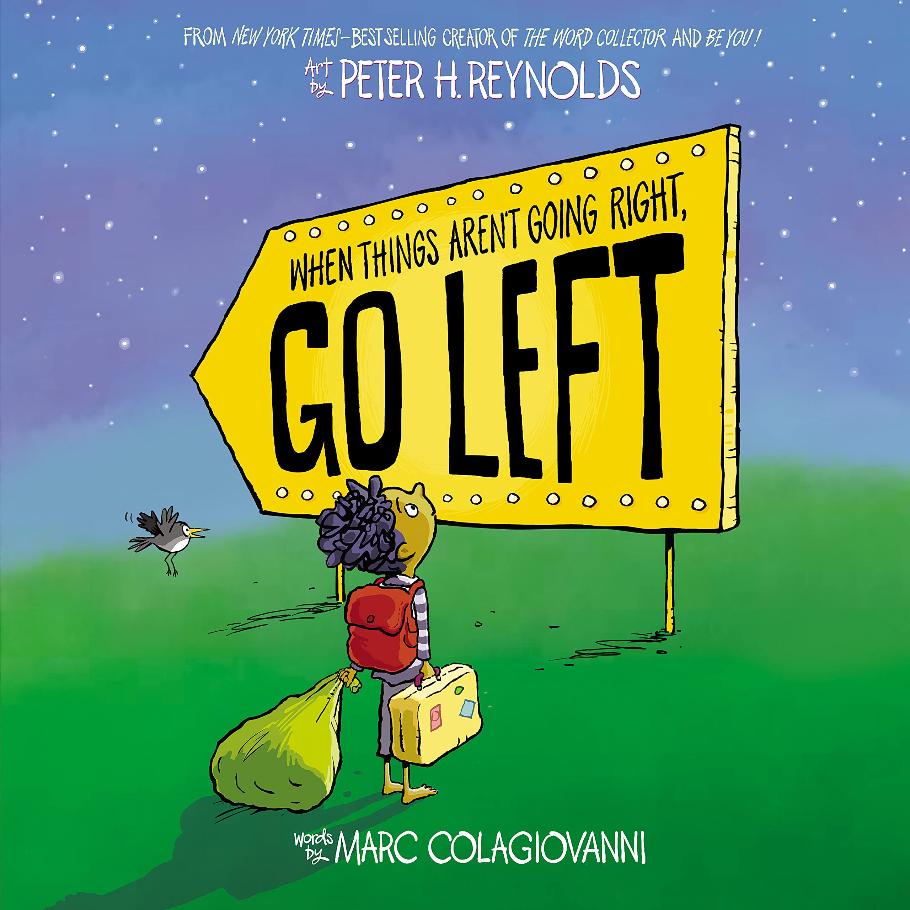 | https://www.youtube.com/watch?v=RjI8-zTsK4o

