Apple Cinnamon Zucchini Muffins

A moist, dense and delicious snack. Super easy! I had apples and zucchini that were just begging to be turned into something wonderful!

By JUSTSMURFY
Prep: 15 mins Servings: 24 Cook: 25 mins Yield: 24 muins Total: 40 mins
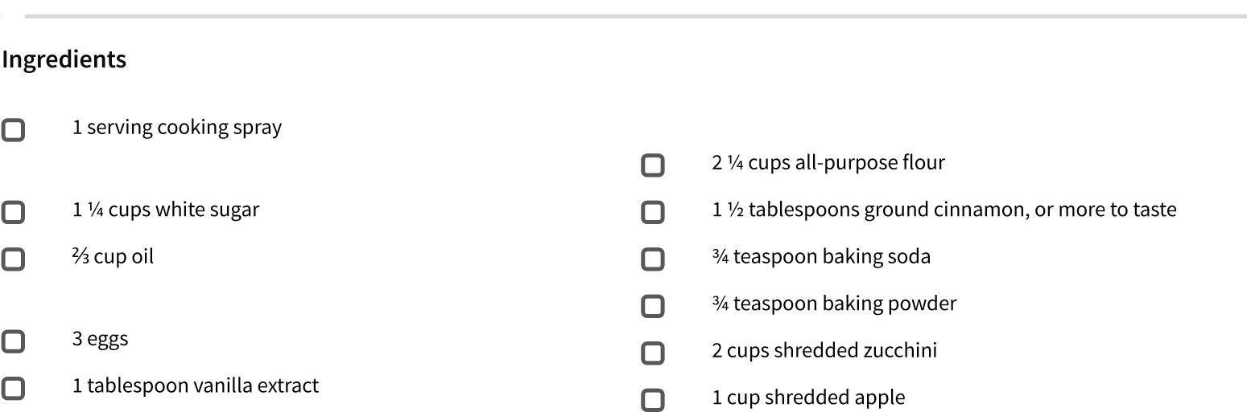

Directions
Preheat oven to 350 degrees F (175 degrees C). Spray 24 mu in cups with cooking spray or line with paper liners.
Whisk sugar, oil, eggs, and vanilla extract together in a bowl until smooth. Stir flour, cinnamon, baking soda, and baking powder into sugar mixture just until batter is combined. Fold zucchini and apple into batter and spoon into the prepared muffin cups.
Bake in the preheated oven until muffins spring back after pressing the top, about 25 minutes.

Cook's Notes: Nutrition Facts
I use a ice cream scoop to make all the muffins even amounts.
Per Serving:152.6 calories; 2.2 g protein; 20.9 g carbohydrates; 23.3 mg cholesterol; 64.7 mg sodium. Tips
I sprinkled autumn colored sugar on top for color and a slight texture.

