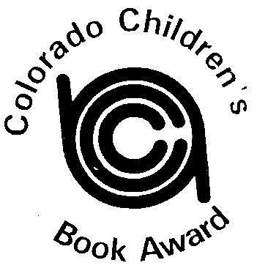
COLORADO CHILDREN’S BOOK AWARD

Sponsored by CCIRA: Empowering Literacy Educators

2023 Picture Book Winner
The Couch Potato
By Jory John and Pete Oswald
2023 Picture Book Runner-Up
Norman Didn’t Do It! (Yes, He Did)
By Ryan T. Higgins

2023 Junior Book Winner
The Bad Guys in Cut to the Chase
by Aaron Blabey
2023 Junior Book Runner-Up
Escape from Chernobyl
by Alex Marino

