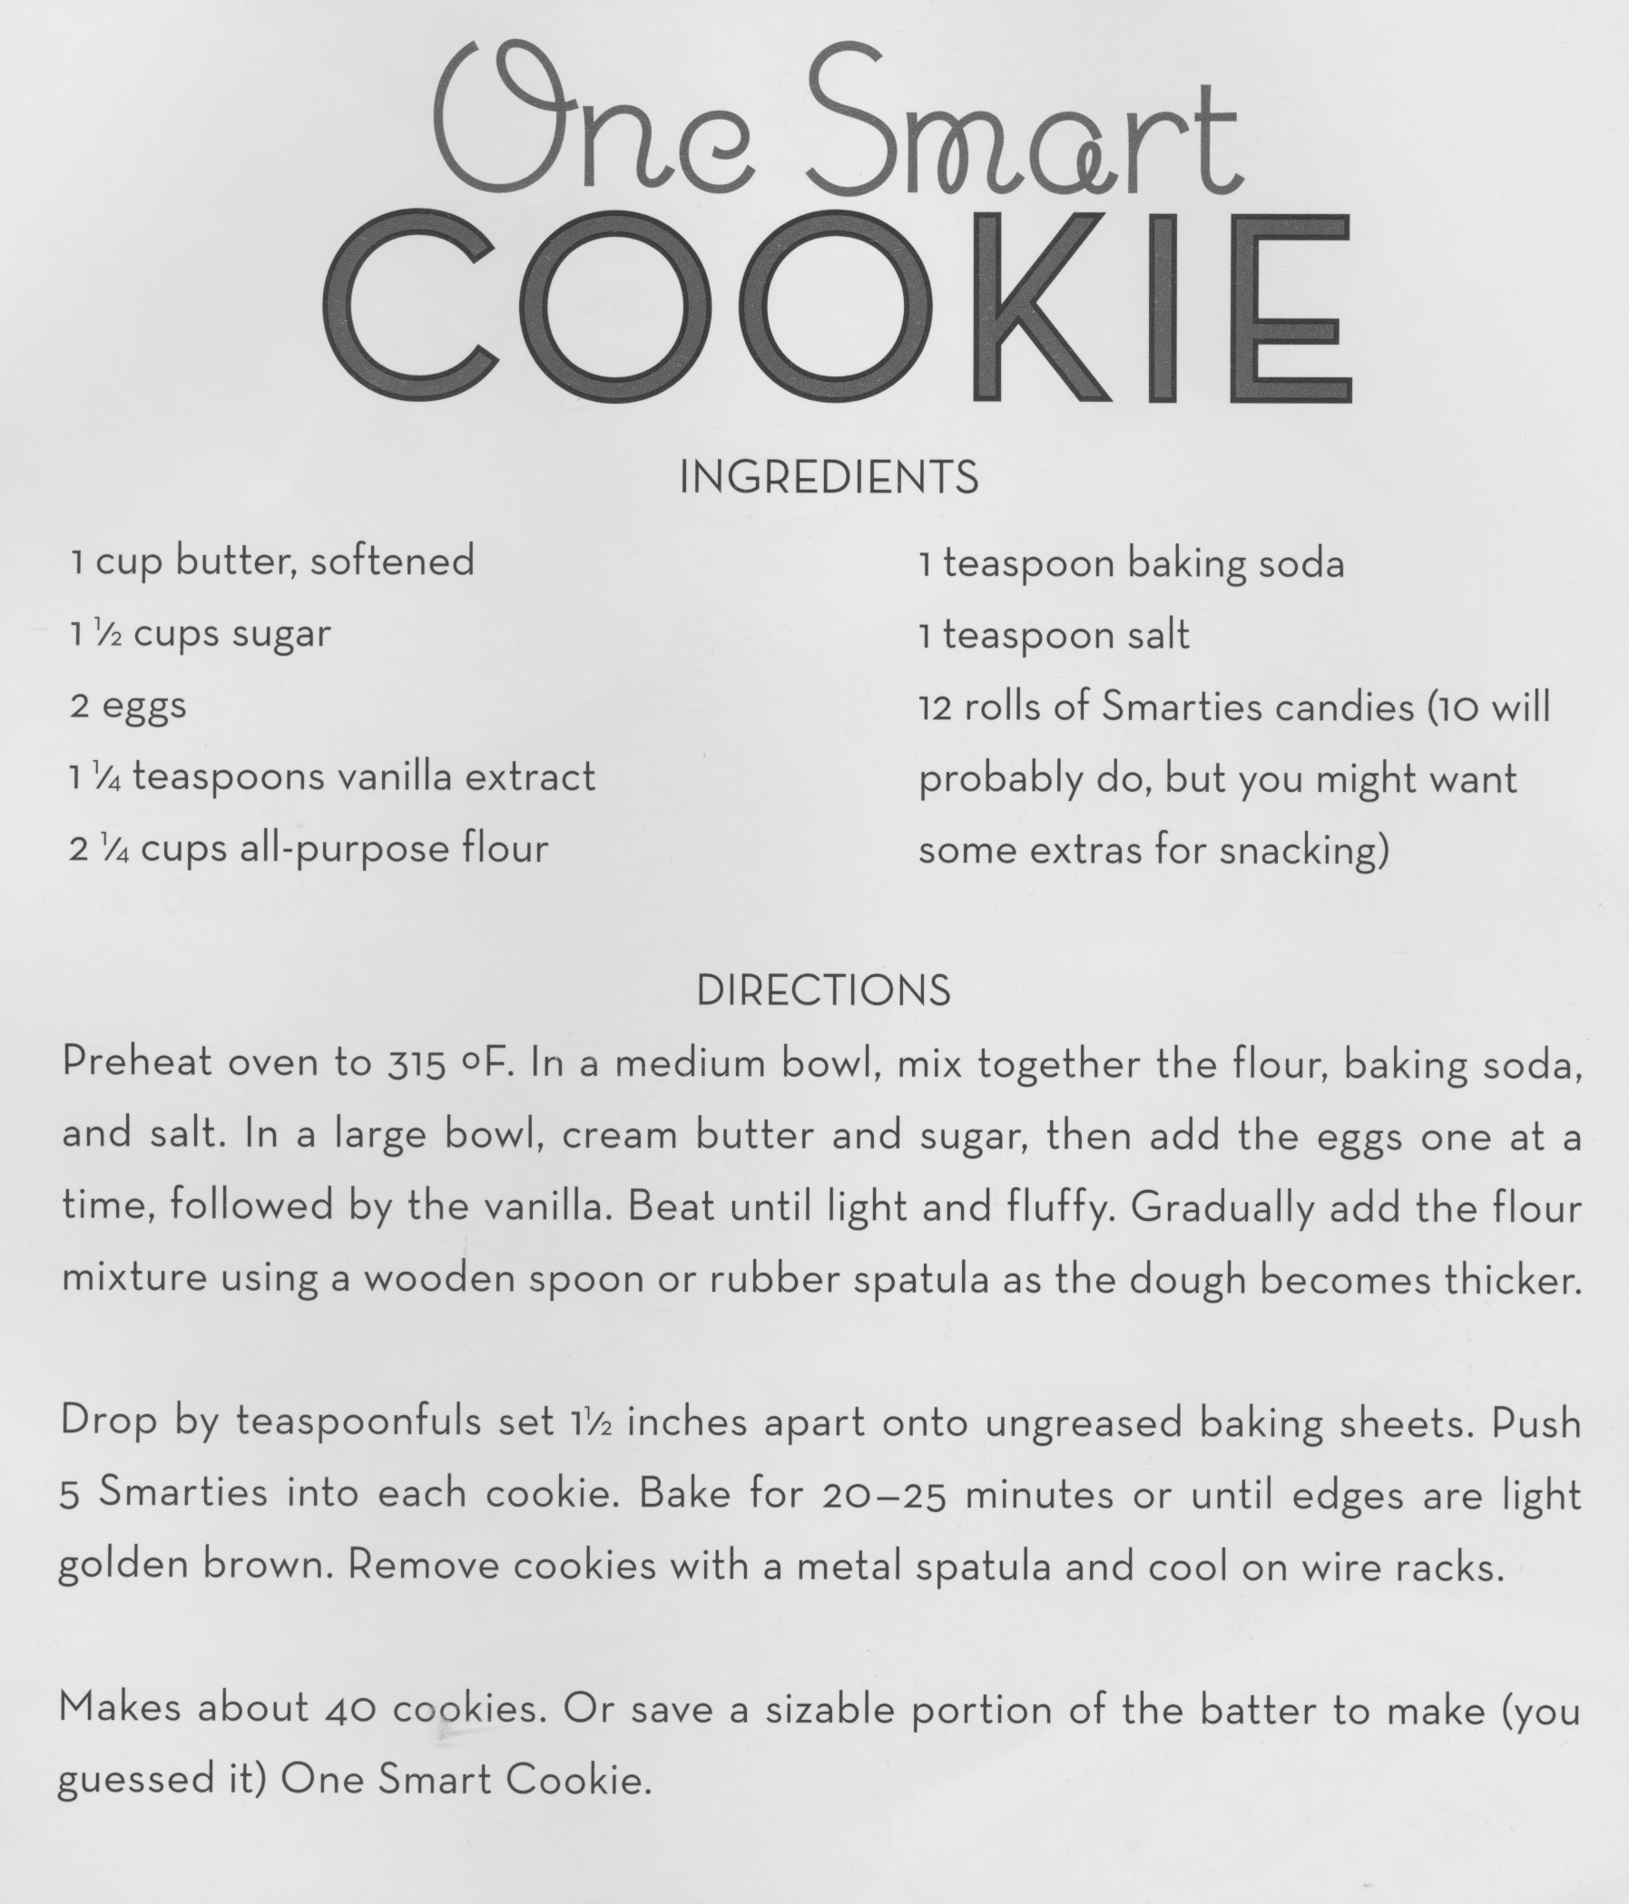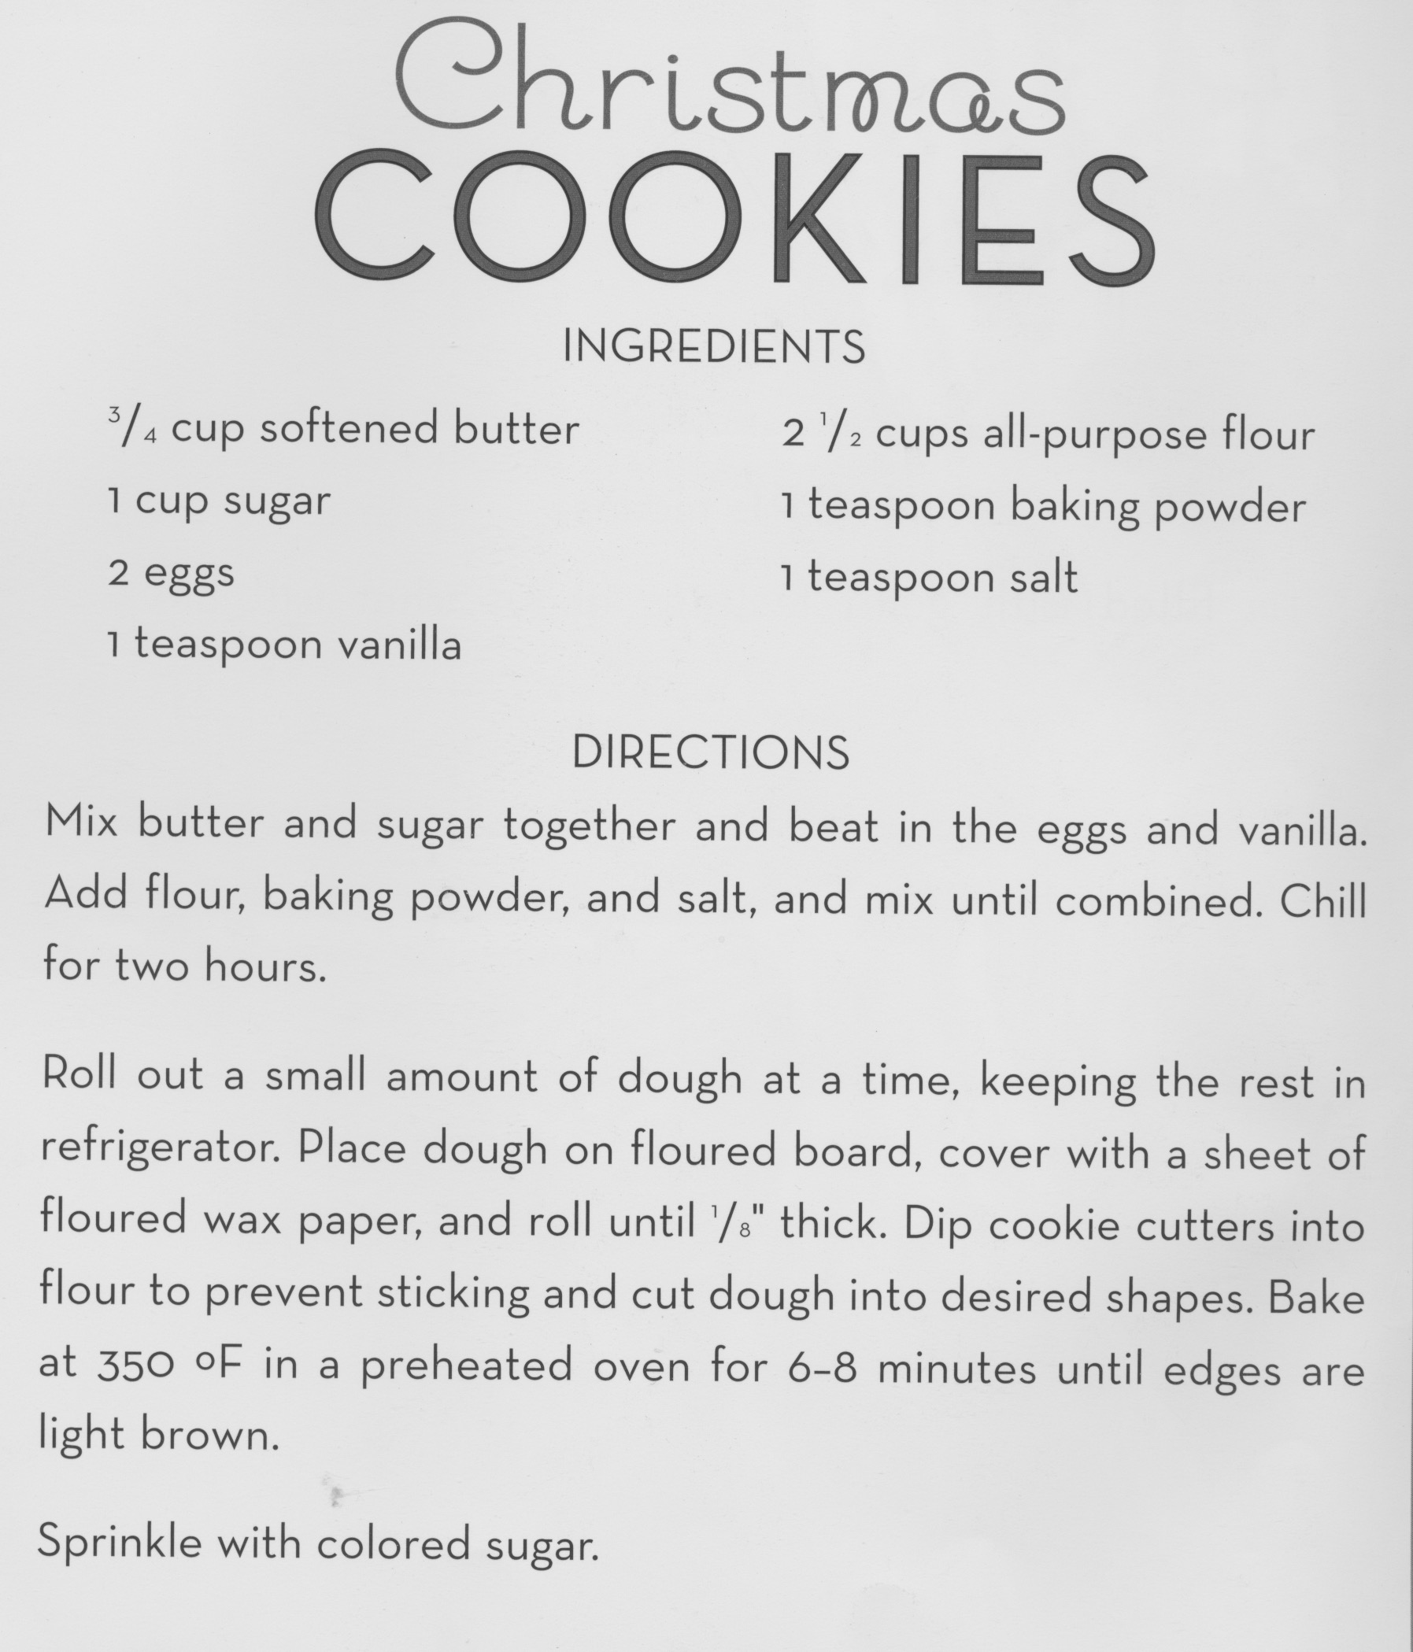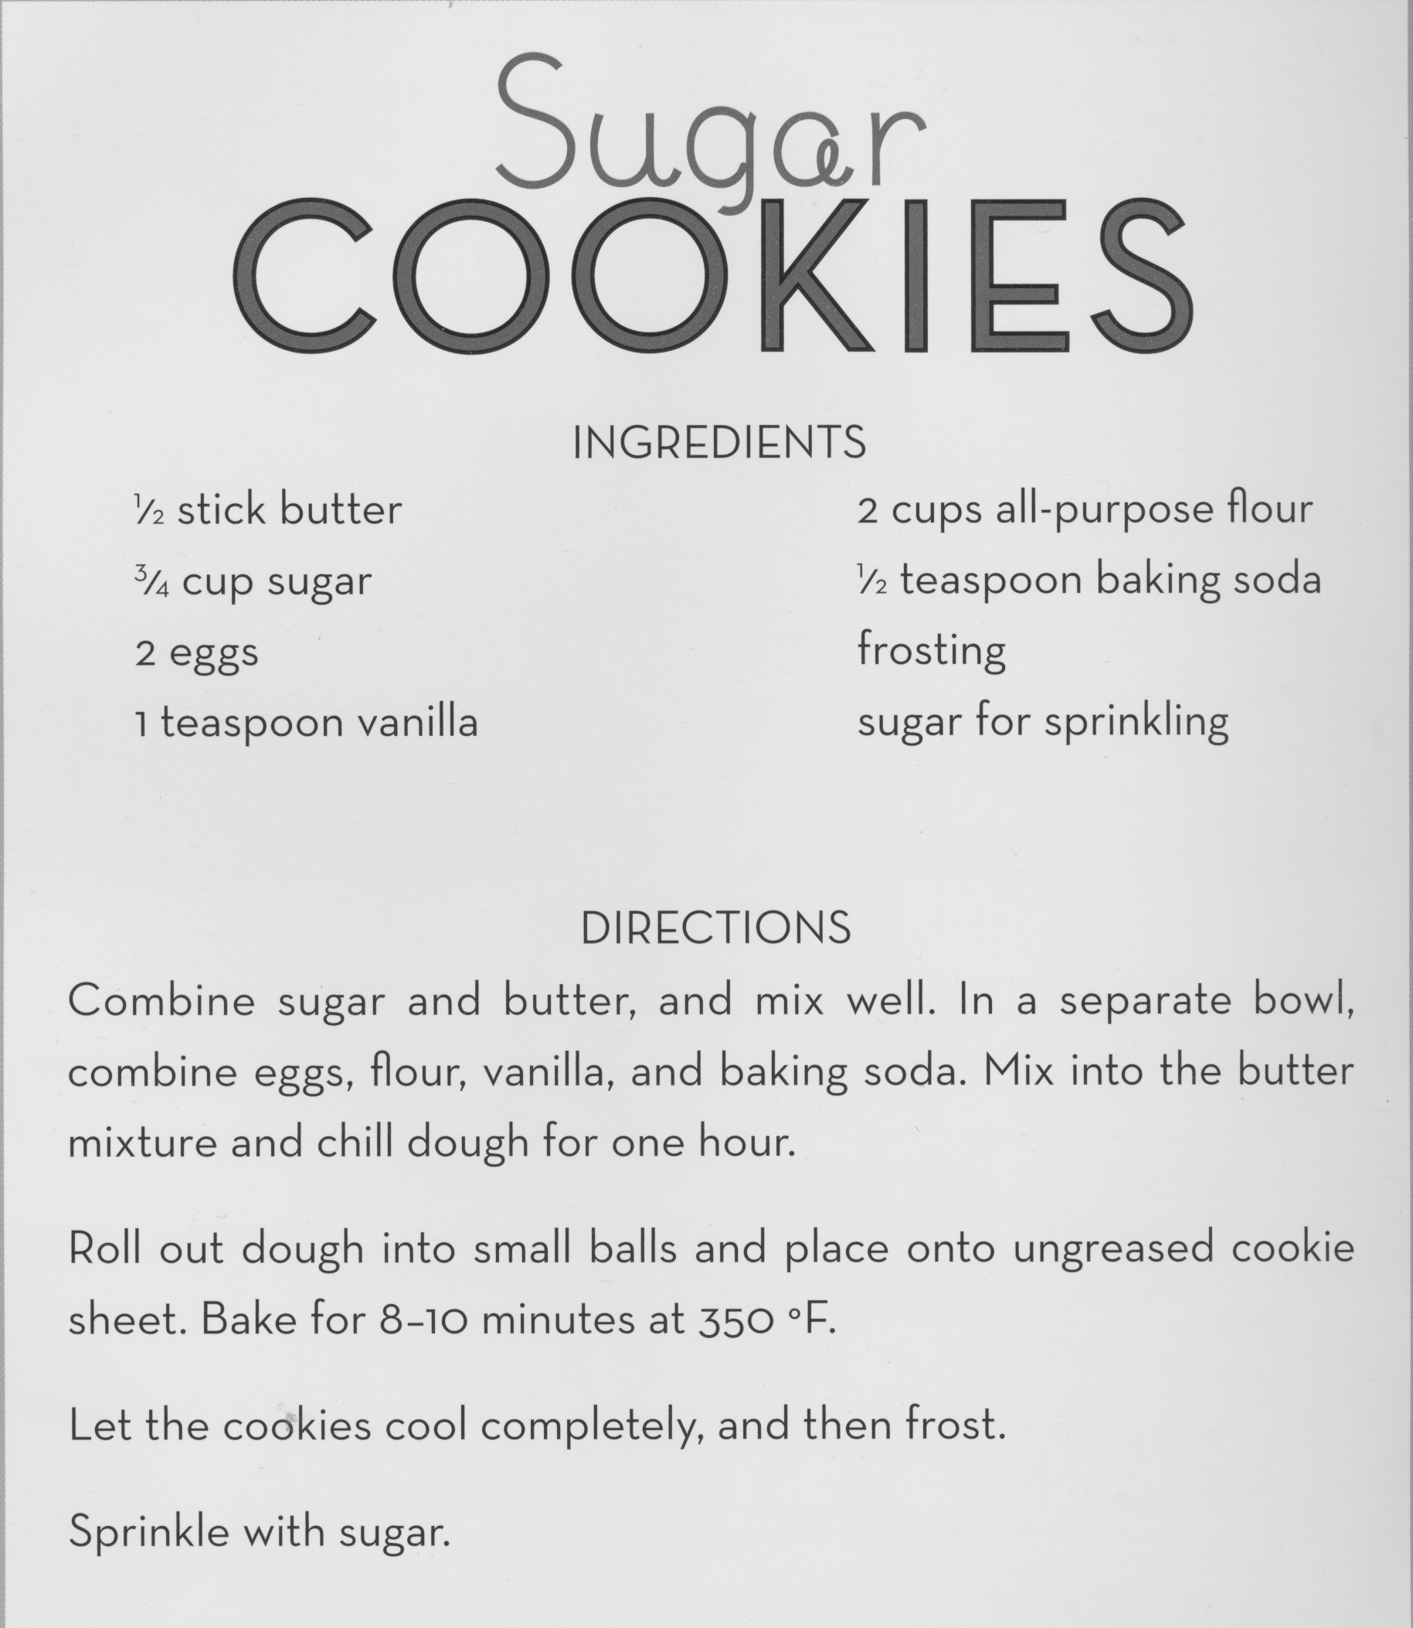

Prompt
Oranized – Unorganized
Prepared – Unprepared
Compromise
Empathy
Kindness
Listening
Contribute
Procrastinate - Diligent
Persevere
Arrogant
Humble
Ponder
Daydream
Creative
Dishonesty
Integrity
Curious
Anticipation - Tradition
Disappointed
Celebrate
Appreciative
Prosperity
Charitable
Responsible - Moderation
Reciprocate
Frustrated
Perseverance
Selfish - Thoughtful
Lonely
Sharing - Gratitude
Family
Gracious
Believe
Joy
Peace – Hope
Endearment
Considerate
Heartfelt
Compassionate
Admire
Forgive
Supportive
Tenderness
Adore
Expansive Love
Constructive
Unconditionally
Connected
Heartbroken
True Love
Selfless
Bliss
Cherish - Protect

