I recently discovered that one of my top ten things I love in life is to make rules or guidelines and then follow them. Rules for my Top Ten booklists are:
1. Copyright the previous year.
2. Not nominated by the children of Colorado for the Colorado Children's Book Award - You can find those at ccira.org/ccba.html
Click on 2014 Nominees.
3. Useful in classrooms and libraries
4. Author or illustrator can only appear once
Top Ten Picture Books for 2012:
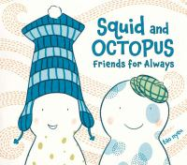
10 - Nyen, Tao (2012) Squid and Octopus: Friends for Always, NY: Dial Books for Young Readers.
These four stories make a great interactive read aloud to pair with Mo Willems' (2011) Hooray for Amanda and Her Alligator. They can also be used as a mentor for writing best friend stories.

9 - Loth, Sebastian (2012) [Translated by David Henry Wilson] Zelda, the Varigoose NY: North South Books.
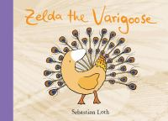
This book uses plastic overlays to transform a goose into a hybrid creature described with a rhyming couplet. It makes an interesting art lesson to have students use acetate and permanent markers to create their own creatures and write their own couplets. This can be paired with D. B. Johnson's (2012) Magritte's Marvelous Hat. This book uses acetate pages and pays tribute to Belgian surrealist Rene Magritte. The author's note can lead to research on a variety of artists.

8 - Hale, Christy (2012) Deaming Up: A Celebration of Building, NY: Lee &
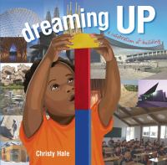
Low Books.

This book contains concrete poetry and introduces architecture from all over the word. It can be used with older students when teaching how to use Google Maps as well as with younger students as an imagination building activity.

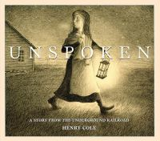
7 - Cole, Henry (2012) Unspoken: A Story from the Underground Railroad, NY: Scholastic.
This wordless picture book tells the story of a farmer's daughter who helps a runaway slave escape. The afterword contains enough information to allow students to write the story in their own words.

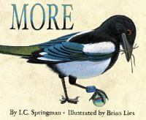
6 - Springman, I.C. (2012) More, illustrated by Brian Lies Boston: Houghton Mifflin/Harcourt.
This book is fun for teaching preschoolers quantity words but contains an anti materialist message great for discussions by older students. The jacket flap spreads the message to adults as well.

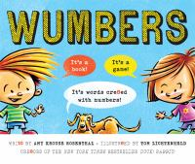
5 - Rosenthal, Amy Krouse (2012) Wumbers: It's Words Cr8ted with Numbers, illustrated by Tom Lichtenheld NY: Scholastic.
Challenging fun for readers old enough to decode and great to pair with the book CDB. "We dedic8 this book 2 William Steig, the cre8or of C D B!"
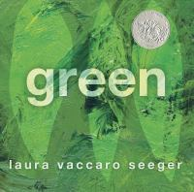
4 - Seeger, Laura Vaccaro (2012) Green, NY: Roaring Brook Press.
This 2013 Caldecott Honor book uses diecut pages to explore the color green. The tie in to ecology and link to how the book is made are very useful classroom tools.

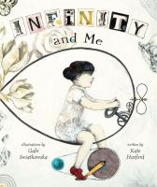
3 - Hosford, Kate (2012) Infinity and Me, illustrated by Gabi Swiatkowska Minneapolis: Carolrhoda Books.
This beautiful story explains infinity in a way that children, and me, can understand. The intergeneration relationship pairs well with Eve Bunting's (1989) The Wednesday Surprise.

2 - Joyce, William (2012) The Fantastic Flying Books of Mr. Morris Lessmore NY: Atheneum Books for Young Readers.
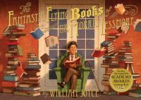
Based upon the 2011 Academy Award Winning Short Film this book pays tribute to books, story, and the printed word. Joyce was inspired by HarperCollins children's book publisher William Morris. The 2011 iPad app is excellent to start off a school year supplying each student with their own journal. A companion augmented reality app, the IMAG-N-O-TRON, can be purchased which brings the pages of the book to life.

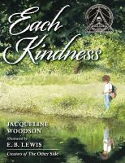
1 - Woodson, Jacqueline (2012) Each Kindness, illustrated by E.B. Lewis NY: Nancy Paulsen Books.
This 2013 collaboration has the power to change lives of both children and adults as they realize the missed opportunities created by not choosing to be kind. The book won the 2013 Jane Addams Peace book Award.

