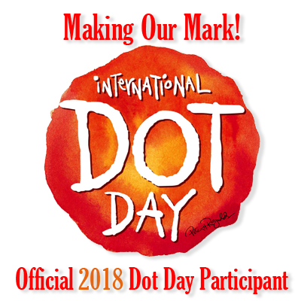
Peter H. Reynolds - International DOT Day - September 15ish 2018
"Stories that matter, stories that move"
Blue Bunny Booksore in Deedham, Massachusettes

"What wondrous things books can be. My favorites are ones that move me---to laughter, to tears, to deep thought, and to action" (2009)
The Dot (2003) You can view on Tumblebooks (must have Broomfield library card) or DVD
ish (2004) also now on Tumblebooks
Write one title you can find in the Library by any of these Celebridots authors /illustrators.
Tom Angleberger ____________________________________________________________________________________
Katherine Applegate ________________________________________________________________________________
Eric Carle ____________________________________________________________________________________________
Sharon Creech ______________________________________________________________________________________
Drew Daywalt _______________________________________________________________________________________
Kate DiCamillo _______________________________________________________________________________________
Lynda Mullaly Hunt _________________________________________________________________________________
Jeff Kinney ___________________________________________________________________________________________
Jon Klassen __________________________________________________________________________________________
Nina Laden __________________________________________________________________________________________
Kirby Larson ________________________________________________________________________________________
Lois Lowry __________________________________________________________________________________________
Wendell Minor ______________________________________________________________________________________
Amy Krouse Rosenthal _____________________________________________________________________________
Judy Schachner _____________________________________________________________________________________
Seymour Simon ____________________________________________________________________________________
David Ezra Stein ___________________________________________________________________________________
Sarah Weeks ________________________________________________________________________________________
Salina Yoon _________________________________________________________________________________________

CREATE A DOT ON THE BACK OF YOUR PAPER

